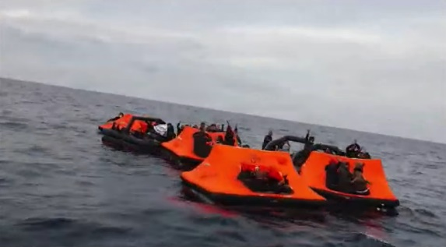
Dear _______________
We at ____________ are registered as an organisation in (country and/or region).
We wish to draw to your attention the ongoing practice of pushbacks in the Aegean Sea, being carried out by the Greek government, and to request you raise this issue at the European Parliament, and oppose it in the strongest possible terms.
From 1 March 2020 to 21 March 2021, NGOs Aegean Boat Report, Legal Centre Lesvos and Mare Liberum have documented 370 incidents of pushbacks, in which 10,898 men, women and children have been forced back from Greek waters – and in an increasing number of cases from the Aegean islands – into Turkish water, against their will.
The video footage and direct eye-witness accounts the organisations have collected reveal that Greek coastguard vessels fire weapons across the bows of boats carrying unarmed men, women and children, and that coastguard and other uniformed Greek officers including port and regular police and members of the armed forces, force these people not even onto boats, but onto engineless life-rafts – effectively inflatable tents – and set them adrift on the open sea.
We feel we must share two particularly harrowing – and distressingly, very recent – episodes.
In the first, on 17 February 2021, two children were taken from a refugee camp on Samos island by Greek officers who told them they would receive COVID-19 tests. Instead, the officers forced them into Greek coastguard vessels and dumped them in a life-raft.
On Friday 19 March 2021, seven men were forced onto a life-raft having had their hands bound with plastic ‘hand-cuffs’.
They were picked up by the Turkish coastguard, but of the seven, two drowned and their bodies have been recovered, one man died having been rushed to Cesme hospital, Turkey, on arrival on land, and one is still missing, presumed dead. That is, at least three, and almost certainly four, innocent people seeking safe places to live, were instead killed by being handcuffed and forced onto life rafts, which were left to drift, by a government of a European member state.
These immoral, unjustifiable and illegal acts are not isolated incidents.
Greek government figures show that from 1 March to 31 December 2020, 3,973 men, women and children were registered as new arrivals at refugee camps on the Aegean islands. But in the same period, 9,741 people were pushed back via sea routes by the Greek government.
From 1 January to 21 March 2021, the Greek government reported that 590 men, women and children were registered at the island refugee camps. In the same period, Aegean Boat Report has documented 46 pushbacks, in which 1,157 men, women and children have – entirely against their will, and in direct breach of international law – been forced into engineless life rafts and set adrift. At least three people have died as a result.
In international circles, the Greek government’s response to these revelations has been to deny them, but within Greek media members of the government have described pushbacks as ‘Greece’s right’ and ‘the right thing for Greek citizens.’
This has not been the government’s sole response. It has also begun to publicly attack the organisations documenting this illegal activity, making evidence-free claims that they – the organisations – are in fact breaking the law. On 16 March 2021, ten Greek aid organisations issued a joint statement specifically requesting that the Greek government ceases carrying out pushbacks, and ceases its attacks on organisations which bring these illegal acts to the public eye.
We do not wish to lecture you on the shocking situations from which these men, women and children have fled. In any case, it is up to the governments of the countries in which they arrive to process their asylum applications and decide whether they qualify for refugee status.
But it is those people’s right to have such an application given full and fair consideration, and it is absolutely illegal – not to mention also immoral – to force innocent men, women and children from EU territory to deny them that right.
As an EU-based organisation, which believes the EU can and should be a beacon of legal and decent behaviour towards people in need, and a protector and promoter of international law, we request that you raise this issue at the European Parliament and in any other EU-related positions you hold.
Please contact us for any further information and to let us know your progress on this vital issue.
Yours sincerely,

_____________________

